Music Clustering Analysis Report
CS 4412 Data Mining
Student: Vu Le
Date: March 14th, 2026
Executive Summary
This report presents a comprehensive clustering analysis of Spotify music tracks. The analysis employed K-Means clustering to group similar songs based on their audio features. The goal was to identify natural patterns in the music dataset and understand how different audio characteristics define distinct music clusters.
The analysis revealed two primary clusters that effectively separate the dataset based on acoustic properties versus electronic characteristics. The findings show that acoustic features serve as the strongest differentiator between music groups.
Dataset Overview
The dataset contains 8,947 music tracks with 19 attributes covering various audio features and metadata. Each track includes measurements for danceability, energy, acousticness, valence, tempo, loudness, speechiness, liveness, and duration, along with genre classification.
Key Features Analyzed
Danceability: Measure of how suitable a track is for dancing (0.0 to 1.0)
Energy: Intensity and activity level of the track (0.0 to 1.0)
Acousticness: Confidence measure of whether the track is acoustic (0.0 to 1.0)
Valence: Musical positivity conveyed by the track (0.0 to 1.0)
Tempo: Overall estimated tempo in beats per minute (BPM)
Loudness: Overall loudness in decibels (dB)
Speechiness: Presence of spoken words in the track (0.0 to 1.0)
Liveness: Presence of audience in the recording (0.0 to 1.0)
Duration: Length of the track in milliseconds
Sample tracks from the dataset include pop, R&B, acoustic, and hip-hop genres with varying characteristics across all features.

Methodology
The clustering analysis followed a structured approach to identify natural groupings in the music data.
Feature Engineering
To enhance the clustering effectiveness, a derived feature was created to capture the relationship between acoustic and electronic properties.
Acoustic-Electronic Ratio: This ratio was calculated as acousticness divided by energy (with a small constant added to prevent division by zero). The ratio was then log-transformed to handle extreme outliers and create a more normally distributed feature.
This engineered feature proved crucial in distinguishing between acoustic-heavy tracks and electronic/energetic music.
Feature Standardization
All features were standardized using StandardScaler to ensure each variable contributed equally to the clustering algorithm. Standardization transforms features to have a mean of zero and standard deviation of one, preventing features with larger scales from dominating the distance calculations.
Optimal Cluster Selection
To determine the best number of clusters, two evaluation metrics were employed across different cluster counts (K=2 to K=6).
Silhouette Score: Measures how similar an object is to its own cluster compared to other clusters. Higher values indicate better-defined clusters.
Davies-Bouldin Index: Measures the average similarity ratio of each cluster with its most similar cluster. Lower values indicate better clustering.
K | Silhouette Score | Davies-Bouldin Index
2 | 0.175 | 1.995
3 | 0.100 | 2.654
4 | 0.086 | 2.591
5 | 0.091 | 2.424
6 | 0.093 | 2.257

Table 1: Clustering evaluation metrics across different K values
Based on these metrics, K=2 emerged as the optimal choice, showing the highest Silhouette Score and lowest Davies-Bouldin Index. This indicates that the music dataset naturally separates into two distinct groups.

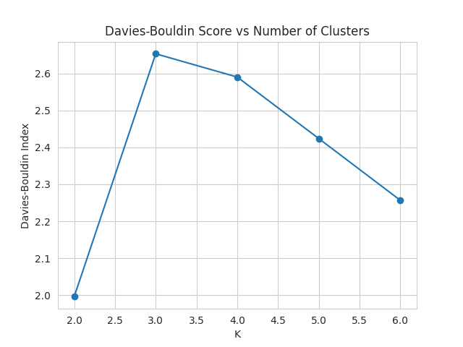

Figure 1: Silhouette Score across different K values showing optimal performance at K=2
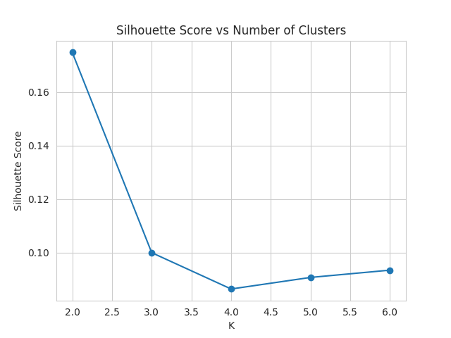


Figure 2: Davies-Bouldin Index across different K values confirming K=2 as optimal

Dimensionality Reduction
Principal Component Analysis (PCA) was applied to reduce the feature space to two dimensions for visualization purposes. This allowed for effective plotting of the clusters while retaining the essential variance in the data.

Results
Cluster Distribution
The K-Means algorithm with K=2 produced two clusters with the following distribution:
Cluster 0: 1,534 tracks (17.1% of dataset)
Cluster 1: 7,413 tracks (82.9% of dataset)
This uneven distribution suggests that one cluster represents a more common musical profile while the other captures a specialized subset of tracks.
Cluster Characteristics
The two clusters showed distinct audio profiles across all features.
Feature | Cluster 0 | Cluster 1
Danceability | 0.591 | 0.597
Energy | 0.056 | 0.358
Acousticness | 0.835 | 0.585
Valence | 0.498 | 0.497
Tempo (BPM) | 118.1 | 118.5
Loudness (dB) | -7.22 | -7.04
Speechiness | 0.077 | 0.075
Liveness | 0.147 | 0.150
Duration (ms) | 214,304 | 212,493
Acoustic/Electronic Ratio | 3.446 | 1.043

Table 2: Average feature values by cluster
Cluster 0 Profile (Acoustic Cluster):
- Significantly higher acousticness (0.835 vs 0.585)
- Much lower energy (0.056 vs 0.358)
- Higher acoustic-electronic ratio (3.446 vs 1.043)
- Slightly quieter (-7.22 dB vs -7.04 dB)
- Similar tempo, valence, and danceability to Cluster 1
This cluster represents predominantly acoustic music characterized by gentler, more organic sounds with lower electronic production.

Cluster 1 Profile (Electronic/Energetic Cluster):
- Lower acousticness, higher energy
- More electronic production characteristics
- Slightly louder and more energetic overall
- Represents the mainstream music profile in the dataset
The most significant differentiating factors between clusters are acousticness, energy, and the derived acoustic-electronic ratio. Other features like tempo, valence, danceability, speechiness, and liveness show minimal variation between clusters.
Visualization
PCA visualization revealed clear separation between the two clusters along the first principal component, which primarily captures the acoustic versus electronic dimension. The scatter plot shows Cluster 0 concentrated in one region while Cluster 1 spreads across a broader area, reflecting its larger size and greater internal diversity.

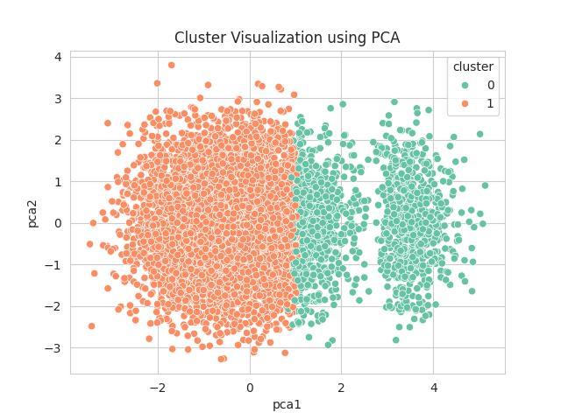

Figure 3: PCA visualization of two clusters showing clear separation between Cluster 0 (acoustic) and Cluster 1 (electronic/energetic)

Deduplication Experiment
To assess whether duplicate tracks affected clustering quality, a deduplication experiment was performed. Tracks with identical track IDs were removed, creating a deduplicated dataset.
The clustering metrics remained identical after deduplication:
Original Dataset - Silhouette: 0.175, Davies-Bouldin: 1.995
Deduplicated Dataset - Silhouette: 0.175, Davies-Bouldin: 1.995
This result indicates that duplicates had negligible impact on the clustering outcome, and the original dataset was already relatively clean with minimal redundancy affecting the analysis.
Discussion
Interpretation of Findings
The analysis successfully identified two meaningful clusters in the Spotify music dataset. The primary division occurs along the acoustic-electronic spectrum, which makes intuitive sense from a musical perspective. Acoustic music and electronic music represent fundamentally different production approaches and listening experiences.
The overwhelming majority of tracks (83%) fall into Cluster 1, the electronic/energetic cluster. This reflects the prevalence of electronically produced or enhanced music in the modern Spotify catalog. Pop, R&B, hip-hop, and other mainstream genres typically involve significant electronic production, placing them in this larger cluster.
Cluster 0, though smaller, represents a distinct musical niche focused on acoustic instrumentation and natural sound. This cluster likely includes folk, classical, acoustic singer-songwriter material, and unplugged versions of songs.
The similarity in danceability, valence, and tempo across clusters suggests these features are independent of the acoustic-electronic dimension. Songs can be danceable, positive, and have various tempos regardless of whether they're acoustically or electronically produced.
Limitations
Several limitations should be acknowledged:
The analysis only tested up to K=6 clusters. More granular clustering might reveal additional subgroups.
Genre information was not used as a clustering feature, though it could provide additional insights.
The acoustic-electronic ratio, while effective, is a simplified representation of production complexity.
Duration and loudness showed minimal variation across clusters, suggesting they may not be strong differentiators for this dataset.

Conclusions
This clustering analysis of 8,947 Spotify tracks identified two primary music clusters based on K-Means algorithm with K=2 as the optimal solution. The clusters separate predominantly along the acoustic-electronic spectrum, with energy and acousticness serving as the strongest differentiating features.
Key findings include:
- K=2 provides the best clustering solution based on Silhouette Score (0.175) and Davies-Bouldin Index (1.995).
- Cluster 0 represents acoustic music (17.1% of tracks) with high acousticness and low energy.
- Cluster 1 represents electronic/energetic music (82.9% of tracks) with balanced acoustic-electronic characteristics.
- The acoustic-electronic ratio proved to be a valuable engineered feature for distinguishing music types.
- Deduplication had no impact on clustering quality, confirming dataset integrity.
Recommendations
Based on these findings, several recommendations emerge:
Music Recommendation Systems: Use these clusters to improve recommendation algorithms by ensuring diversity between acoustic and electronic music recommendations.
Playlist Curation: Create playlists that respect cluster boundaries to maintain consistent musical atmosphere.
Further Analysis: Explore subclusters within Cluster 1 to identify more granular groupings in the electronic/energetic music category.
Feature Development: Consider additional engineered features that capture other musical dimensions beyond acoustic-electronic spectrum.
Genre Integration: Incorporate genre information in future analyses to validate cluster interpretations and discover genre-cluster relationships.
The analysis demonstrates that even with relatively simple audio features, meaningful musical patterns can be identified through clustering techniques. The acoustic-electronic dimension emerges as a fundamental organizing principle in contemporary music catalogs.

References
[1] Rousseeuw, P. J. (1987). Silhouettes: A graphical aid to the interpretation of cluster analysis. Journal of Computational and Applied Mathematics, 20, 53-65. https://doi.org/10.1016/0377-0427(87)90125-7
[2] Davies, D. L., & Bouldin, D. W. (1979). A cluster separation measure. IEEE Transactions on Pattern Analysis and Machine Intelligence, 1(2), 224-227. https://doi.org/10.1109/TPAMI.1979.4766909
[3] Zaki, M. J., & Meira, W. (2020). Data Mining and Machine Learning: Fundamental Concepts and Algorithms (2nd ed.). Cambridge University Press. Chapter 13: Clustering, pp. 337-371.
[4] Thorndike, R. L. (1953). Who belongs in the family? Psychometrika, 18(4), 267-276. https://doi.org/10.1007/BF02289263
[5] Quinlan, J. R. (1986). Induction of decision trees. Machine Learning, 1(1), 81-106. https://doi.org/10.1007/BF00116251
[6] Jolliffe, I. T., & Cadima, J. (2016). Principal component analysis: A review and recent developments. Philosophical Transactions of the Royal Society A, 374(2065), 20150202. https://doi.org/10.1098/rsta.2015.0202
[7] Breunig, M. M., Kriegel, H. P., Ng, R. T., & Sander, J. (2000). LOF: Identifying density-based local outliers. ACM SIGMOD Record, 29(2), 93-104. https://doi.org/10.1145/335191.335388
[8] Spotify for Developers. (2024). Web API Audio Features. https://developer.spotify.com/documentation/web-api/reference/get-audio-features
[9] Zaki, M. J., & Meira, W. (2020). Data Mining and Machine Learning (2nd ed.). Chapter 19: Decision Tree Classifier, pp. 491-516.

